Project 7

By: Eric Dockery

**Custom Chapter 23 Problem**

**Problem:**

In chapter 23 we created two entities BNRItem and BNRAssetType using Core Data and established two relations between them. We also created a button on the bottom bar to allow us to display and select the asset type associated with our item. In this assignment you need to add another relation named BNRAssetLocation with an attribute called location whose values are “Den”, ”Family Room”, “Bed Room”, and “Kitchen” and such that:

* 1. An item can only exist in one location, e.g. my bed can only be located in my Bed Room.
  2. A location can contain many items

Add another button on the bottom bar that will allow you to display and select the location of the asset and have it display locations in the same fashion we displayed assetTypes.

**Solution:**

There was a lot to solve this problem, I am not sure if it was because my experience with CoreData is limited or if I just misunderstood key components in the lecture. First part of this process was creating the BNRAssetLocation Entity in the Homepwner.xcdatamodeld CoreData file. This BNRAssetLocation needed an Attribute of roomLocation Type String and a Relationship room Destination BNRItem inverse assetLocation. Then you add the relationship in BNRItem CoreData the relationship assetLocation Destination BNRAssetLocation Inverse room. Then add the @property (nonatomic, retain) NSManagedObject *assetLocation; to the BNRItem.h file. Make sure to give the BNRAssetLocation a Type of To Many!

Then add the @dynamic assetLocation; to the BNRItem.m file.

Next you have to add the -(NSArray *)allRoomLocations; to the itemStore header and add the nessary code for the roomLocation array to the implementation file (see code document.)

Then in the BNRDetailViewController you need to add the BarButton item to the .xib and then implement the correct calls for the button to the implementation and header files(see code document for more details.)

Lastly, you need to create the code for the BNRAssetLocation which is mostly a copy of the BNRAssetTypeViewController files.

**Screenshot:**

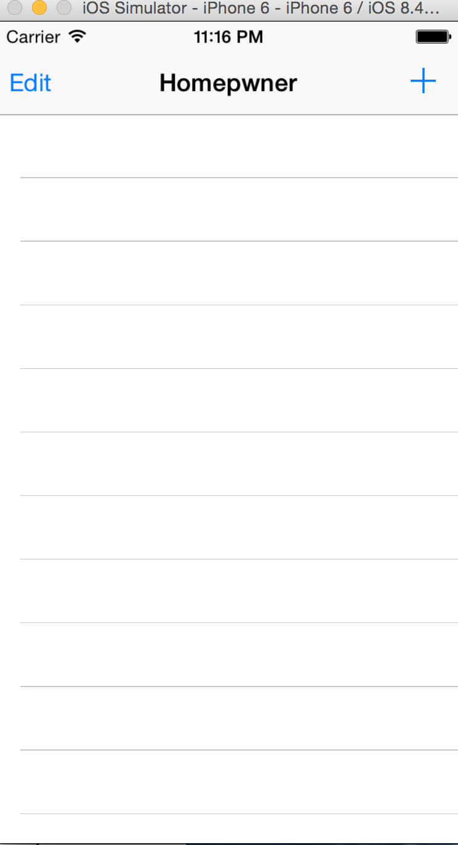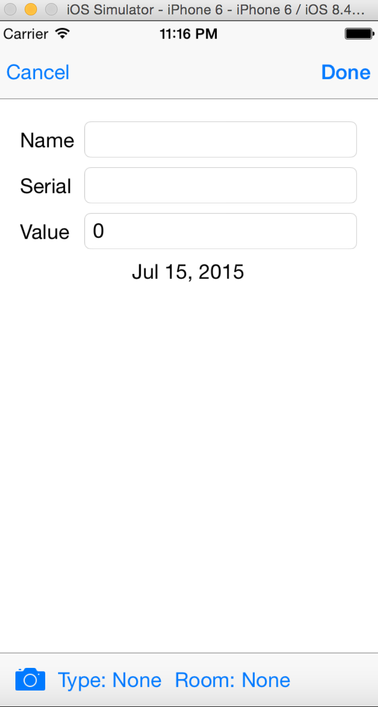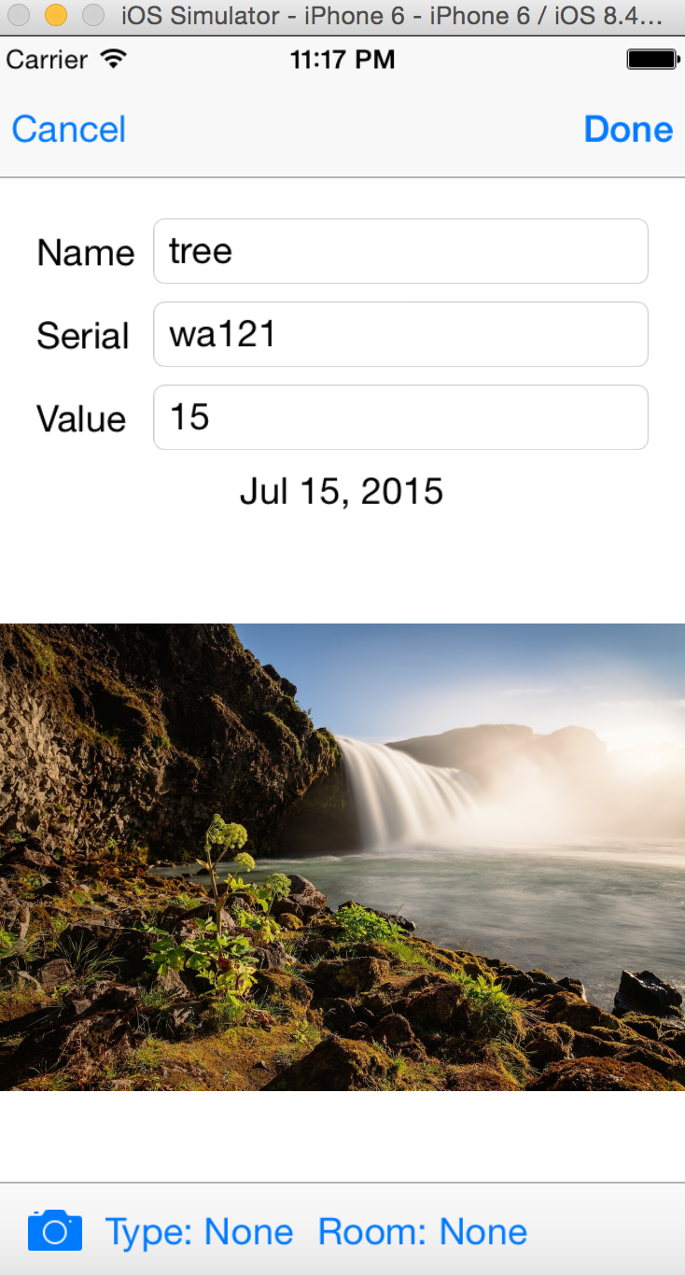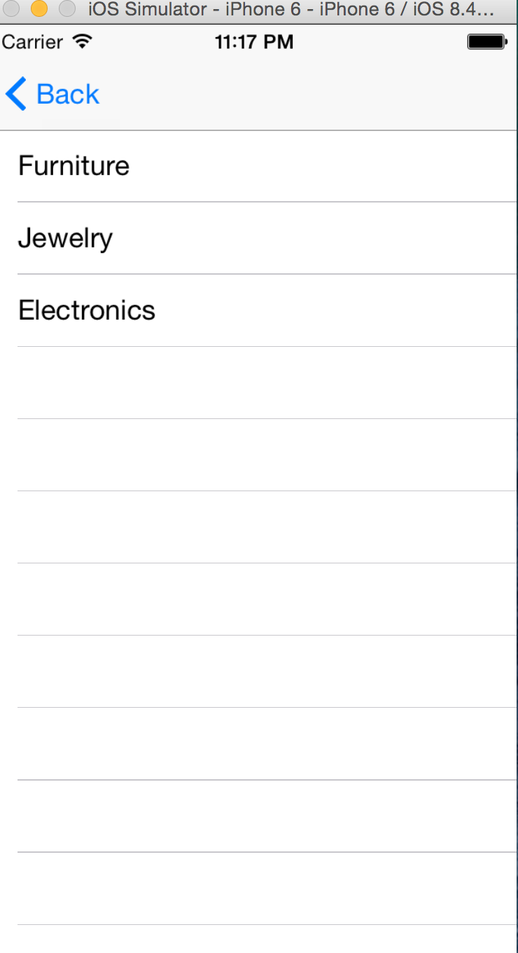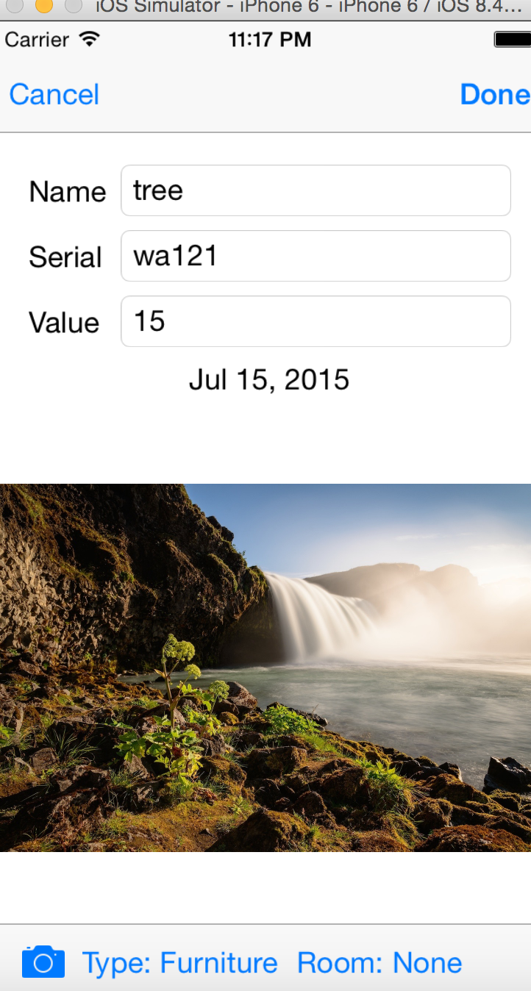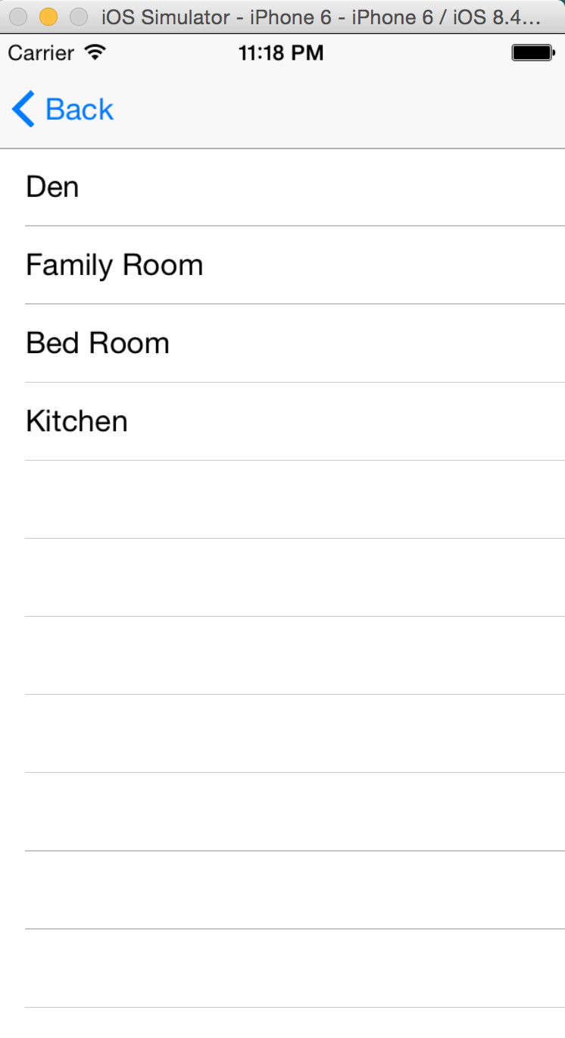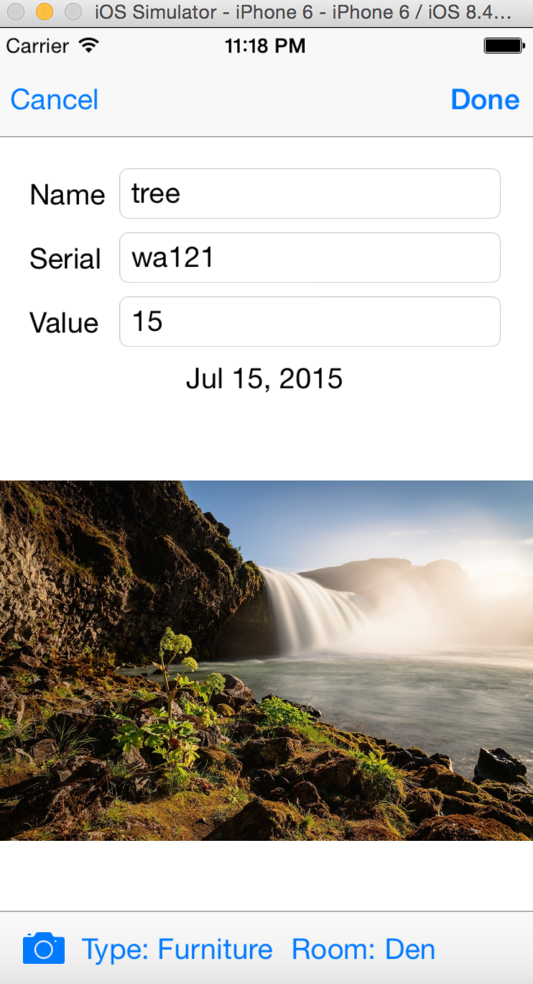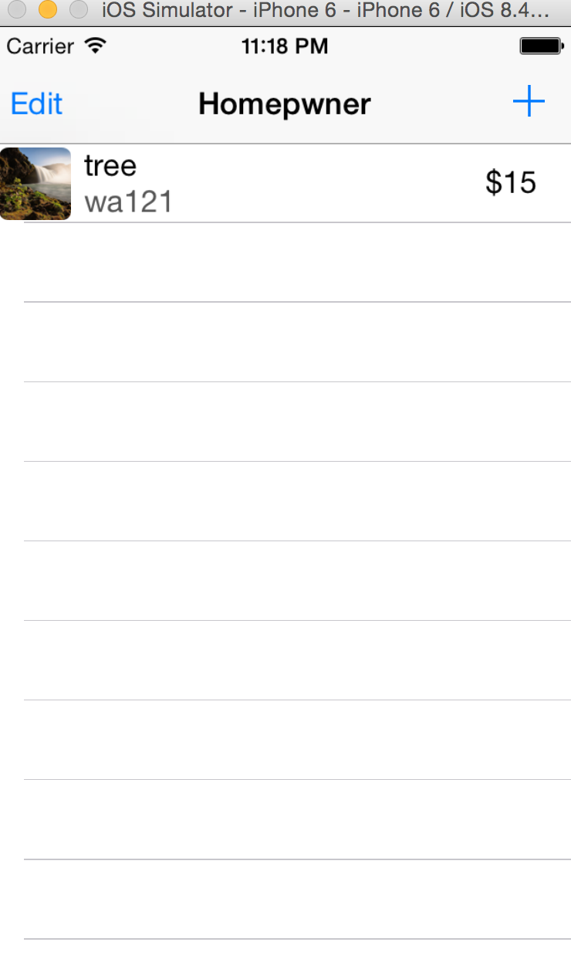

**Two Items in the same room:**